System specifications:

* FPGA Cypress CY8CKIT-059 PSoC 5LP Prototyping Kit. model: CY8C5888LTI-LP097
* Step Motor SST55D3C020 SHINANO KENSHI CO.LTS.JAPAN
* Nikon 2s700-601 PCB Pulse Motor Drive
* 2 Power Suppliers 220V/36V 250W TDK-Lambda SCB and 220V/5V
* Infra-red Sensors Nikon J1
* Breadboard
* Rare Earth Magnet
* Conveyor belt
* LEDS PCB

FPGA – CY8CKIT-059 is a low-cost platform micro-processor that will be sufficient for our project. Its purpose is to receive the signals about the magnet current position from the sensors and a signal for the position we want the magnet to be at, process those signals and output the needed signals for the fitting operation to occur.

Figure - FPGA Micro-processor

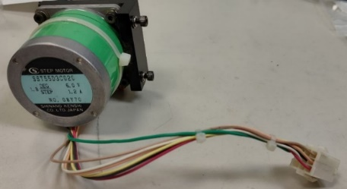Step motor- The purpose of the step motor is to bring closer or farther the magnet for increasing or decreasing the magnetic field strength for the measurement, it will be controlled by the micro-processor.

Figure - Step motor

PCB Pulse motor drive – The purpose of this PCB is to control the step motor using power from the power suppliers. This PCB includes optocouplers, Stepping motor controller and connections to the suppliers and to the motor through Stepper motor driver.

Figure - PCB pulse motor

Power suppliers – Two AC/DC power suppliers, one with output of 36V and the other with output of 5V.

Figure - Power suppliers

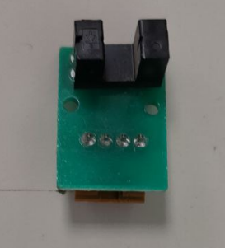Infra-red sensor – The infra-red sensor works by emitting light from one side and has an output voltage depending on if the light was received at the other side or not, the magnet will block light passage if it is above the sensor.

Figure - Infra-red sensor

Breadboard – On the breadboard we plan to wire the micro-processor and the other external resistors for the sensors. In the future we plan to replace the breadboard with a printed Interface board.

Figure - Breadboard

Rare Earth Magnet – The strongest permanent magnet which developed in the 1980s.

Figure - Rare Earth Magnet

Conveyor Belt – On the conveyor belt the model moves and the magnetic field will change correspondingly.

Figure - Conveyor belt

LEDs PCB – This PCB purpose is to indicate where the model is at the moment since the whole measurement process will be in a black box.

Figure - LEDs PCB